**MID TERM III EXAMINATIONS 2022**

**S.5BIOLOGY / 1**

**Time: 1 hours 45 minutes**

**Instructions:**

*Answer all questions in this paper*

*Answers to section A must be written in the table below.*

*Answers to section B must be written only in the spaces provided.*

**SECTION A (40 Marks)**

|  |  |  |  |  |  |  |  |
| --- | --- | --- | --- | --- | --- | --- | --- |
| **1.** | **6.** | **11.** | **16.** | **21.** | **26.** | **31.** | **36.** |
| **2.** | **7.** | **12.** | **17.** | **22.** | **27.** | **32.** | **37.** |
| **3.** | **8.** | **13.** | **18.** | **23.** | **28.** | **33.** | **38.** |
| **4.** | **9.** | **14.** | **19.** | **24.** | **29.** | **34.** | **39.** |
| **5.** | **10.** | **15.** | **20.** | **25.** | **30.** | **35.** | **40.** |

1. Which one of the following is the role of cholesterol in a plasma membrane?

**A**. Reduces escape or entry of non-polar molecules

**B**. Reduces escape or entry of polar molecules

**C**. Reduces escape or entry of organic molecules

**D**. Prevents drying up of the membrane.

1. Which of the following changes in a cell is true as its water potential becomes **less negative**?

**A**. Decrease in turgor pressure **C**. Increase in solute potential

**B**. Decrease in osmotic potential **D**. Decrease in pressure potential

3. The major similarity between active transport and facilitated diffusion is that in both;

**A**. energy is used.

**B**. materials are transported against a concentration gradient

**C**. carrier proteins are involved.

**D**. movement of polar molecules is involved.

4. At what stage of cell division would the cell stop when colchicine is added?

**A**. Metaphase **C**. Prophase

**B**. Anaphase **D**. Telophase

1. The respiratory pigment found in some arthropods is

**A**. haemoerythrin **C**. chlorocruorin

**B**. haemoglobin **D**. haemocyanin

1. In which part of the chloroplast are complex carbohydrates are made?

**A**. Intermembrane space **B**. Inner membrane

**B**. Stroma **D**. Thylakoid

1. A certain gene of a bacterium codes for a protein; 40 amino acids long. How many nucleotides are needed to code for this polypeptide?

**A**. 40 **B**. 80 **C**. 120 **D**. 1600

1. The association of white egrets with herds of cattle can be described as

**A**. Mutualism **C**. Parasitism

**B**. Commensalism **D.** Co-evolution

1. In which of the following processes is osmosis least involved?

**A**. long distance transport of xylem sap.

**B**. swelling of guard cells.

**C**. root pressure

**D.** water movement between neighbouring cells of the root cortex.

1. Why does the absorption spectrum for chlorophyll and the action spectrum for photosynthesis coincide?

**A**. Photosystems I and II are activated by different wavelengths of light.

**B**. Wavelengths of light that are absorbed by chlorophyll trigger light-capturing reactions.

**C**. Energy from wavelengths absorbed by carotenoids is passed on to chlorophyll.

**D**. The rate of photosynthesis depends on the amount of light received.

1. Which of the following summarizes Mendel’s law of segregation?

**A**. Pairs of factors are inherited independent of each other.

**B**. the two homologous chromosomes with a pair of genes and end up separately.

**C**. unlike chromosome pair separate at the spindle equatorial region.

**D**. adjacent genes on a chromosome are never found in the same gamete

1. Which one of the following characteristics is **not** true about all arteries?

**A**. Carry blood away from the heart.

**B**. Lack valves.

**C**. Blood flows under high pressure.

**D**. Have thick muscular walls.

1. The importance of photolysis in the light stage of photosynthesis is that it releases

**A**. Electrons to stabilise chlorophylls in photosystem II.

**B**. Electrons to stabilise chlorophylls in photosystem I.

**C**. Hydroxyl ions which maintain pH.

**D**. Oxygen molecules used in respiration.

1. In which of the following stages of the Calvin cycle is reduced NADP used? Conversion of

**A**. Ribulose diphosphate to phosphoglyceric acid.

**B**. Phosphoglyceraldehyde to hexose sugar.

**C**. Hexose sugar to starch.

**D**. Phosphoglyceric acid to phosphoglyceraldehyde.

1. Which one of the following water relations is not true about a plasmolysed plant cell?

**A**. Turgor pressure is zero.

**B**. Pressure potential is equal to osmotic potential of sap.

**C**. Pressure potential is zero.

**D**. Water potential of cell is equal to osmotic potential of sap

1. A tissue showed numerous lysosomes in cells when viewed under a microscope. Which one of the following is the possible cause?

**A.** Active transport

**B.** Infection

**C.** High rate of internal transport

**D.** High rate of protein synthesis

1. Which of the following organelles forms a new cell wall between daughter cells during plant cell division?

**A.** Golgi apparatus.

**B.** Lysosomes

**C.** Micro bodies.

**D.** Centrosomes

1. Which one of the following is the final electron acceptor in non-cyclic photophospholylation?

**A.** Cytochrome.

**B.** Ferrodoxin.

**C.** NADP

**D.** Oxygen

1. Which of the following is **incorrect** about C4 plants? They

**A.** Fix carbondioxide using the Enzyme PEP carboxylase.

**B.** Fix carbon dioxide using RuBP carboxylase.

**C.** Efficiently fix carbondioxide at high temperatues.

**D.** Use less energy than C3 plants.

1. The importance of photolysis in the light dependent stage of photosynthesis is that it releases

**A.** elctrons to stablise chlorophylls in photosystem II.

**B.** Electrons to stabilize chlorophylls in photosystem I.

**C.** Hydroxyl ions to maintain pH

**D.** Oxygen molecules used in respiration.

1. Crossing over exchanges alleles between

**A**. non-homologous chromosomes

B. Non-sister chromatids

**C**. non-homologous chromatids

**D**. Sister chromatids

1. Which one of the following is most likely to occur when a plant is allowed to photosynthesize under very low carbon dioxide levels?

**A.** glycerate-3-phosphate accumulates

**B.** Rubulose biphosphate accumulates

**C.** Both rubulose biphosphate and glycerate-3-phosphate accumulate

**D.** Both rubulose bi-phosphate and glycerate-3-phosphate reduce

23. Which of the following conditions would lead to Bohr Effect in a mammal?

**A**. Decrease in pH of blood

**B**. Increase in the oxygen partial pressure in the environment

**C**. Decrease in the metabolic rate.

**D**. Increse in environmental temperature.

24. A partially closed ductus areteriosus in an individual causes

**A**. High blood pressure

**B**. Shortage of oxygen to the tissues

**C**.Heart attack

**D**. Anaemia

25. During protein synthesis, the anticodon base sequence of tRNA is AUG.

What is the base squence on the DNA template strand?

1. UAC
2. ATG
3. AUG
4. TAC

26 Which of the following organisms possess a heart that pumps only deoxygenated blood?

1. Birds
2. Mammals
3. Amphibians
4. Fish

27. A plant which is poory lignified , has poorly developed xylem tissue with large airspaces in the stem and leaves belongs to the group of

**A**. esophytes

**B**. Hydrophytes.

**C**. Halophytes

**D**. Xerophytes

28. Sucrose is the major transport form in plants because it

**A**. Is highly soluble so can be in high concentration in sap

**B**. Can be easily converted to glucose and fructose.

**C**. Is insoluble so it can not be used in chemical reactions.

**D**. Can be oxidized by the living part of the phloem.

29.which of the following types of plant cells provides strength with flexiblility?

**A**. Parenchyma

**B**. Tracheids

**C**. Collenchyma

**D**.Sieve tubes.

30. the following equation summarises aerobic respiration of glucose.

C6H12O6  + 6O2  6CO2 +6H2O +38ATP

If the energy released on oxidation of 1 mole of glucose is 2880KJ and one ATP contains 30.6KJ of energy, what is the percentage efficiency of aerobic respiration of glucose in the equation?

**A**. 40%

**B**.38%

**C**.68.6%

**D**.94.1%

31. In breeding, propagation of a variety with desirable characteristics is referred to as

**A**. Hybridisation

**B**. Artificial selection.

**C**. Cross breeding.

**D**. In breeding.

32. an organism living in an oxygen deficient environment has

**A**. Haemoglobin that easily picks up oxygen

**B**. its oxygen dissociation curve is to the right

**C**. Haemoglobin that easily releases oxygen.

**D**. haemoglobin that less readily picks up oxygen.

33. which one of the following structures is not homologous with the rest?

**A**.Bat wing

**B**. human fore arm.

**C**. Insect wing

**D**. Bird wing

34.Which of the following would lead to a lower respiratory quotient?

**A**. Respiration in muscles during heavy exercise

**B**. Formation of Calcareous scales.

**C**. Fattening livestock.

**D**. Preparation for hibanation in a mammal.

35.which one of the following is the ultimate hydrogen acceptor during anaerobic respiration in animals?

**A**. Lactic acid

**B**. NAD.

**C**.Pyruvic acid

**D**. Acetyladehyde.

36. which of the following when in high levels increases the heart beat rate?

**A**. Carbondioxide

**B**. thyroxine.

**C**. Oxygen.

**D**. Adrenaline.

37. which of the following does not have an effect on anon competitive inhibition?

**A**.temperatrure change.

**B**.pH change.

**C.** Enzyme concentration.

**D**. substrate concentration

38. blood flow in the heart of an insect is as a result of

**A**. raising the perivisceral membrane.

**B**. Contraction of the alary mouscles.

**C**. Relaxation of heart ligaments.

**D**. Increase in the pericardial pressure.

39. large steroid molecules diffuse easily through the surface membranes because the

**A**.membranesconsist of non polar molecules

**B**. Are semi-permeable.

**C**. Are freely permeable.

**D**. Are made of polysaccharides.

40.Which of the following describes the turnover number of an enzyme?

**A**. number of molecules affected by an enzyme.

**B**. number of substrate molecules turned into producys per minute.

**C**.Number of product molecules formed.

**D**. number of substrate molecules catalyzed per minute.

**SECTION B (30 MARKS)**

1. 41. a). State the principle of limiting factors. (02 marks)

……………………………………………………………………………………………………

……………………………………………………………………………………………………

……………………………………………………………………………………………………

b) Scientists investigated the effects of temperature and light intensity on the rate of photosynthesis in creeping azalea. They investigated the effect of temperature on the net rate of photosynthesis at three different light intensities. They also investigated the effect of temperature on the rate of respiration. The graph shows the results.

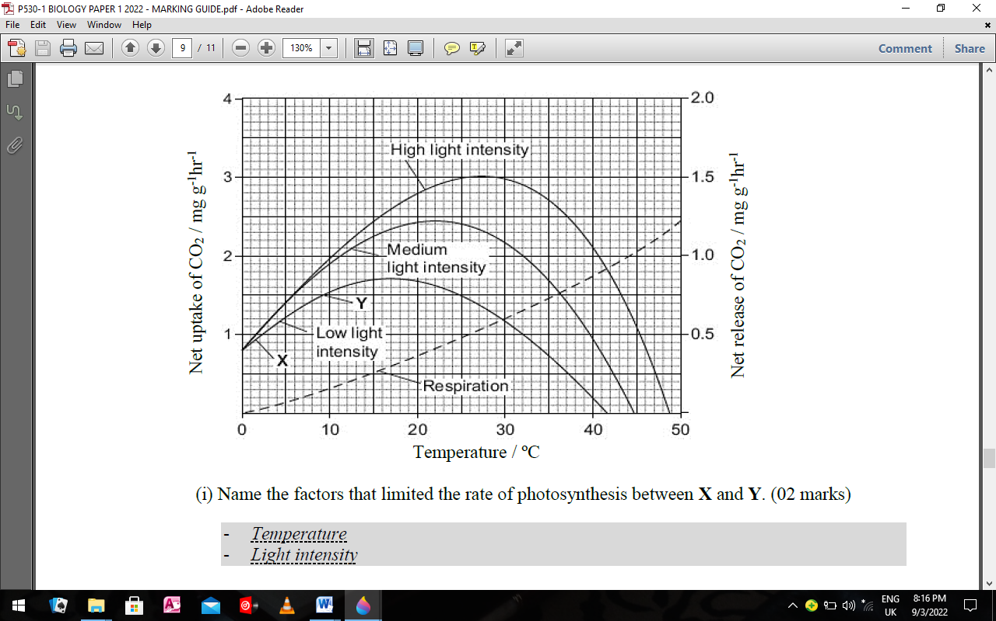

(i) Name the factors that limited the rate of photosynthesis between **X** and **Y**. (02 marks)

……………………………………………………………………………………………………

……………………………………………………………………………………………………

ii) Use information from the graph to explain your answer. (02 marks)

……………………………………………………………………………………………………

……………………………………………………………………………………………………

iii) From the graph, determine the gross rate of photosynthesis at 20°C and medium light intensity.

(01 mark)

……………………………………………………………………………………………………

……………………………………………………………………………………………………

***c) Creeping azalea*** is a plant which grows on mountains. It is predicted that in the area where this plant grows, the mean temperature is likely to rise from 20°C to 23°C. It is also likely to become much cloudier. Describe and explain how these changes are likely to affect the respiration, photosynthesis and overall growth of *creeping azalea*. (03 marks)

……………………………………………………………………………………………………

……………………………………………………………………………………………………

……………………………………………………………………………………………………

……………………………………………………………………………………………………

42.below is the structure of the heart showing movement of electrical excitations.use it to answer the questions following

vagus nerve

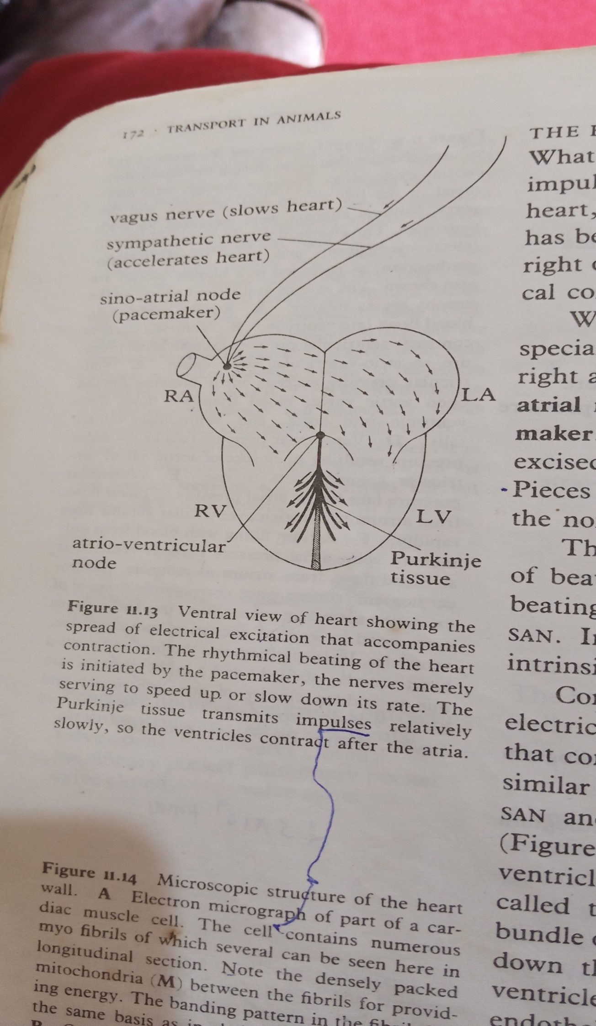

A

B

(a)(i)Name the parts labeled ( ½ Mark @ )

A……………………………………………………………………………………………………

B……………………………………………………………………………………………………

(ii) State the role of each the parts labeled above (1 mark @)

A……………………………………………………………………………………………………

…………………………………………………………………………………………………….

B……………………………………………………………………………………………………

……………………………………………………………………………………………………..

(b) (i) Explain the role of the vagus nerve in controlling the heart beat (02 marks)

……………………………………………………………………………………………………

……………………………………………………………………………………………………

(ii) briefly describe how the cardiac muscle is adapted to its function (02 marks)

……………………………………………………………………………………………………

……………………………………………………………………………………………………

……………………………………………………………………………………………………

……………………………………………………………………………………………………

(c) State three factors which affect blood pressure. (03 marks)

……………………………………………………………………………………………………

……………………………………………………………………………………………………

……………………………………………………………………………………………………

43. Distinguish between continuous and discontinuous variation. (02 marks)

……………………………………………………………………………………………………

……………………………………………………………………………………………………

……………………………………………………………………………………………………

(b) Explain how each of the following causes variation in sexually reproducing organisms.

(i) crossing over during meiosis (04 marks)

……………………………………………………………………………………………………

……………………………………………………………………………………………………

……………………………………………………………………………………………………

……………………………………………………………………………………………………

……………………………………………………………………………………………………

(ii) independent assortment of chromosomes in meiosis (02 marks)

……………………………………………………………………………………………………

……………………………………………………………………………………………………

……………………………………………………………………………………………………

(c) explain the importance of variations in natural selection. (02 marks)

**END**